**PRACTICAL 7**

**AIM: Simulate CoAP protocol in contiki os.**

**THEORY:**

Constrained Application Protocol (CoAP) is a specialized web transfer protocol for use with constrained nodes and constrained networks in the Internet of Things. CoAP is designed to enable simple, constrained devices to join the IoT even through constrained networks with low bandwidth and low availability. It is generally used for machine-to-machine (M2M) applications such as smart energy and building automation. The protocol was designed by the Internet Engineering Task Force (IETF), CoAP is specified in IETF RFC 7252.

**CoAP Features**

* Web Protocol Used in M2M With Constrained Requirements
* Asynchronous Message Exchange
* Low Overhead
* Very Simple To Perform Syntactic Analysis
* Uniform Resource Identifier
* Proxy and Caching Capabilities

**IMPLEMENTATION:**

Step 1: First, we have to create new simulator in Cooja simulator.

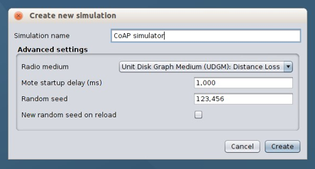

Step 2: Now, create sky mote name router from rpl-border-router and select file borderrouter.c.Compile the file and set quantity as 1.

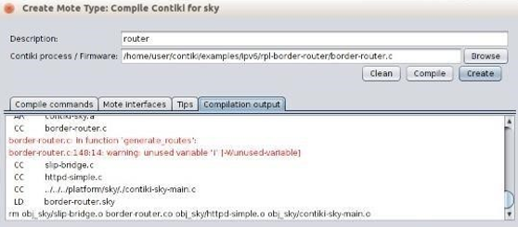

Step 3: Create 2nd sky mote and name as server, select file from er-rest-examples>er-server- example-server.c. Begin the compilation of file.

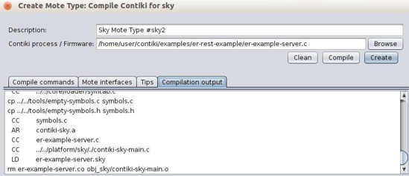

Step 4: Take 2 server motes.

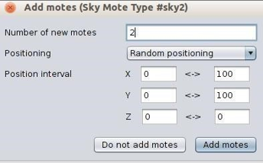

Step 5: Check the serial socket of server

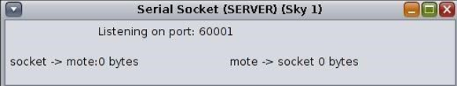

Step 6: Make the connection of router and server by giving the command in terminal.

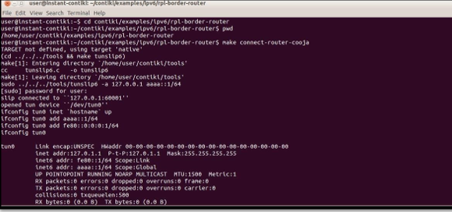

Step 7: Now start the simulation and measure/analyse the network. Set the 3rd node in such a way that it is not in the range of router.

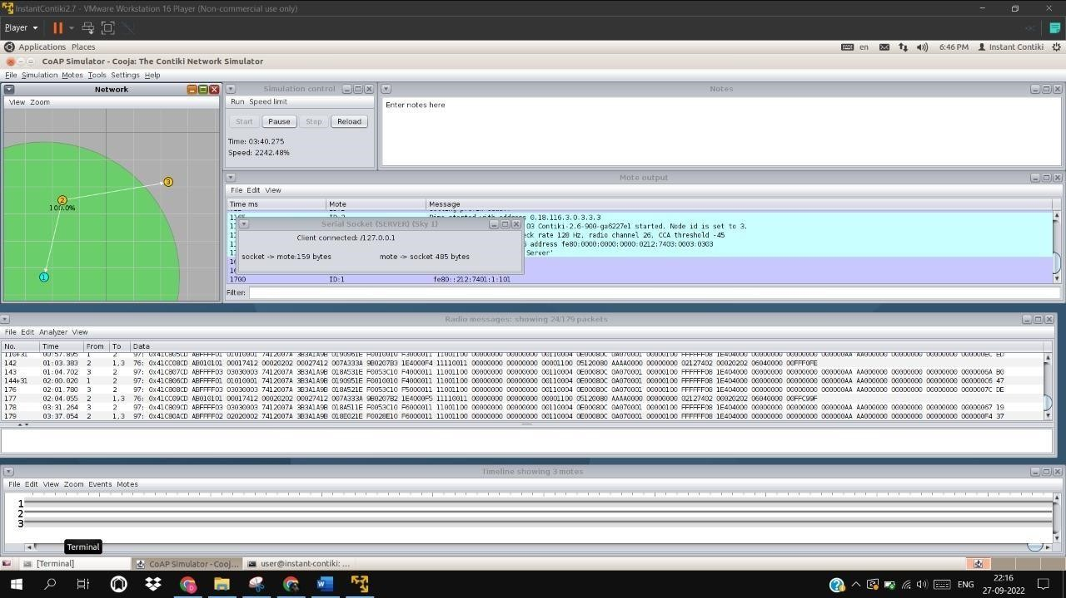

Step 8: Put the address of server in the browser.

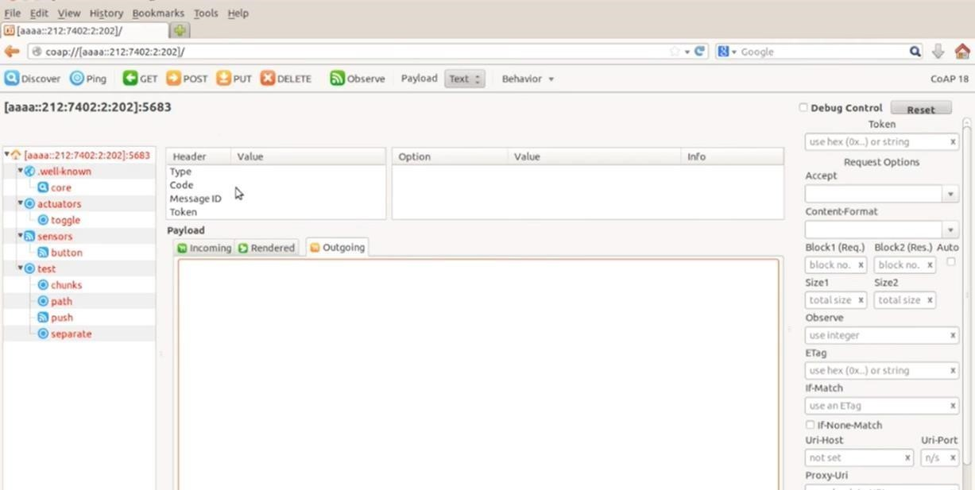

Step 9: Select core and click the get button, we can see the results of testing, sensors, actuators.

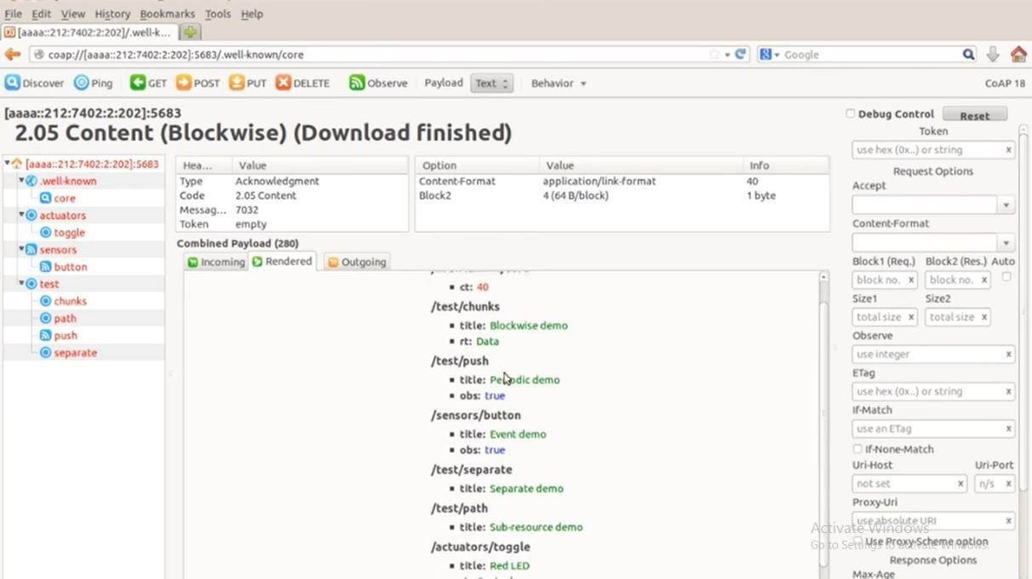

Step 10: Now click the toggle button and give 1 in the outgoing section and post the data on the network.

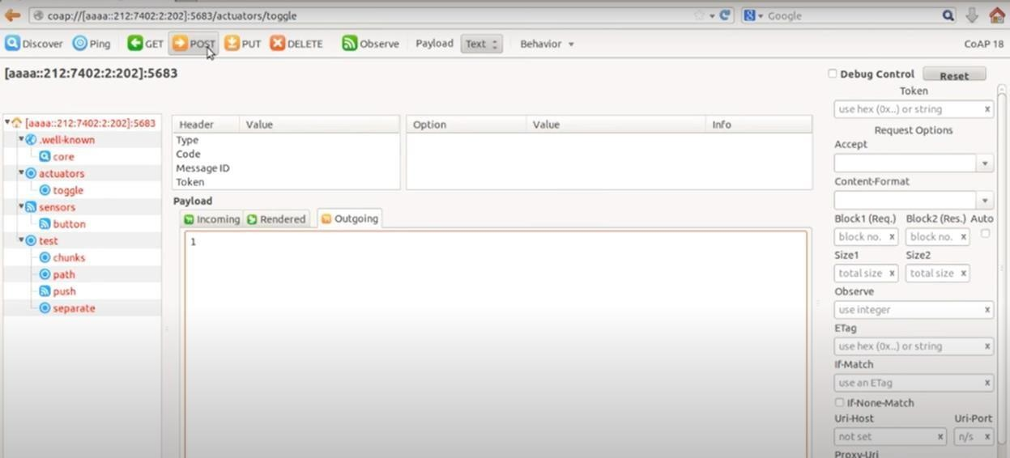

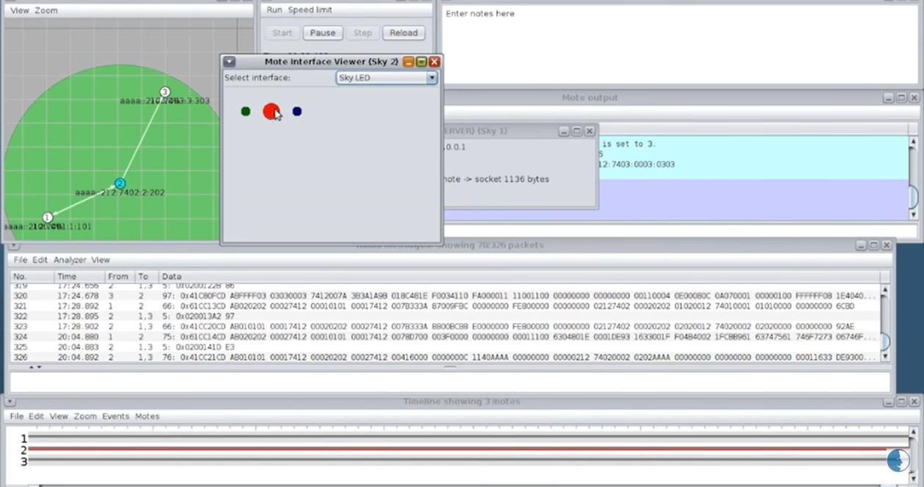

**CONCLUSION:**

By performing this practical, we are able to learn CoAP Protocol.